Surname: DITLHOTLHOLE Initials: K.J.D
Student ID: 202002023

2.iiii. Output: -rw-r—r—1 dit02023 dit02023 30 Feb 27 12:37 first.sh

2.v. Output: -rwx------ 1 dit02023 dit02023 30 Feb 27 12:37 first.sh

2.vi. Output: Hello World

3. Types of Variables = Environmental and Local variables

4. A simple variable declaration statement within a shell script
STUDENT= “Joy”

5.The command used to list all environmental variables
env

6. All environmental variables starting with a “P”
PWD
PATH

7. The output for echo PATH is
PATH
The output for echo $PATH
The difference is that the command starts all the directories in the path separated with a colon.

8. The command that will print the value of dog is
echo $DOG

9.
a. [ndlovuk@linuxnix common]$
\u@\h \w \$
That is username, connected server, the current directory and prompt character.

b. [root@linuxnix dev]*
\h,connected server and dev is the current directory.
This one doesn’t have a prompt character like the first one. It doesn‘t have a username like the first one

10.
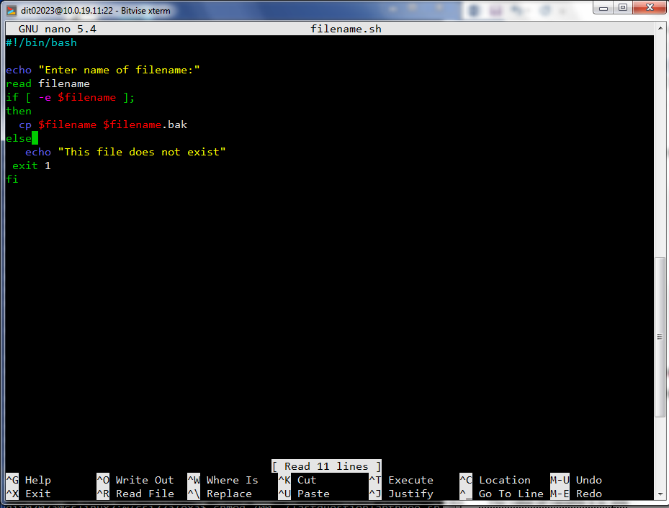
#!/bin/bash
echo “Enter name of filename:”
read filename
if [ -e $filename ];
then
cp $filename $filename.back
else
echo “This file does not exist”
exit 1
fi

11. The output for sparameters.sh John, mary, Jane was
3; ./sparameters.sh; John,; mary,; John, mary, Jane; John, mary, Jane

John, mary and Jane are somewhat printed 3 times.

12. The output is:
The value of variable x is: paper
The value of variable x is: pencil
The value of variable x is: pen

How it is displayed:
In the for loop, the statement “The value of variable x is:” is printed 3 times. “x” in this case is paper, pencil, pen thus the statement will be printed 3 times. I typed ./ and the file name and the output was displayed.

